Batch: A1 Roll No.: 16010123012

Experiment / Assignment / Tutorial No.: 02

Grade: AA / AB / BB / BC / CC / CD /DD

Signature of the Staff In-charge with date

Title: Application of RSA Algorithm using OpenSSL
______________________________________________________________________Objective: Application of RSA Algorithm for various security services like confidentiality, authentication, signature, non-repudiation and integrity
_____________________________________________________________________
Expected Outcome of Experiment:

Course Outcome | After successful completion of the course students should be able to
 | Generate private and public keys , encrypt and decrypt files using aes , des etc , generate a hash file , digital signature and certificate and its verification.
______________________________________________________________________
Books/ Journals/ Websites referred:
https://www.openssl.org/
______________________________________________________________________
Abstract:
This experiment was conducted to understand the fundamentals of OpenSSL and its
role in implementing cryptographic security mechanisms. Various cryptographic
operations were performed, including symmetric encryption using DES, public–private
key pair generation using RSA, hashing using SHA-512, digital signature creation and
verification, and digital certificate generation. Through hands-on execution of
OpenSSL commands, the experiment demonstrated how confidentiality, integrity,
authentication, and non-repudiation are achieved in modern security systems. The
activity provided practical exposure to real-world cryptographic tools, enhancing
understanding of how secure communication and data protection are implemented in
practice.
Related Theory:
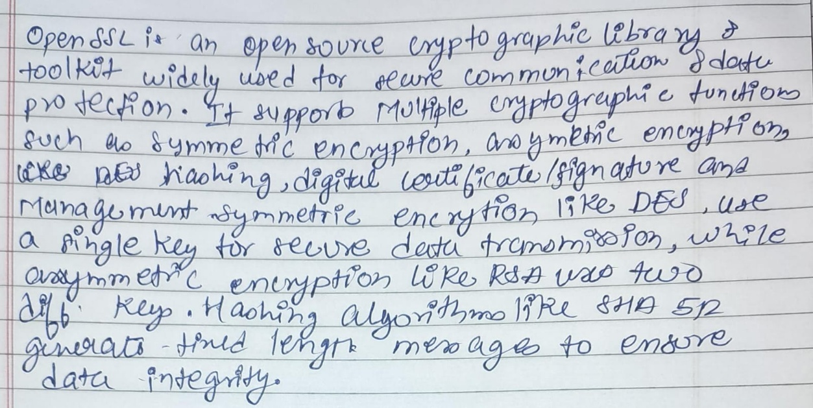
Implementation Details:
Creation of files
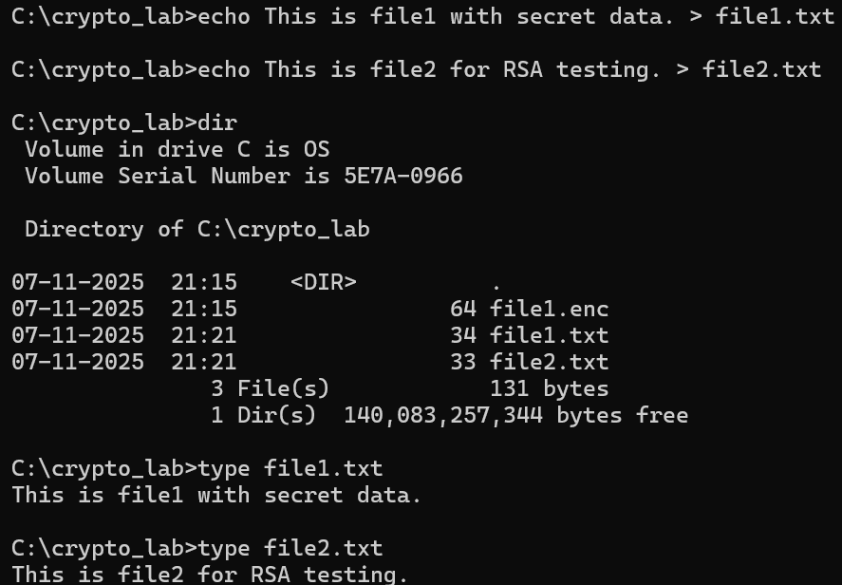AES Symmetric Encryption & Decryption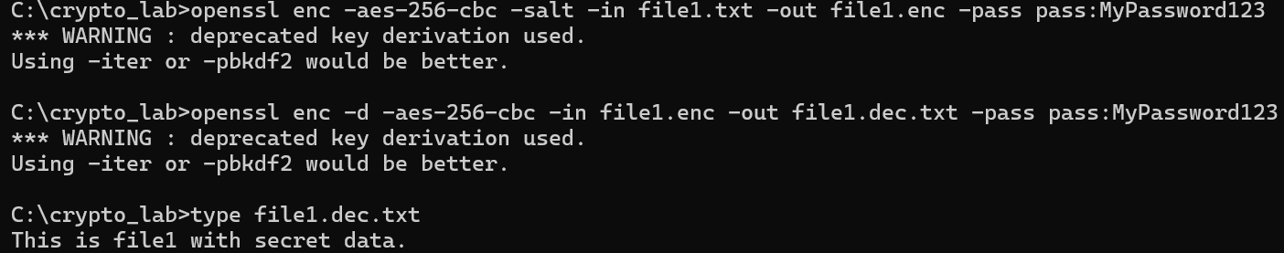Hashing
RSA Key Pair Generation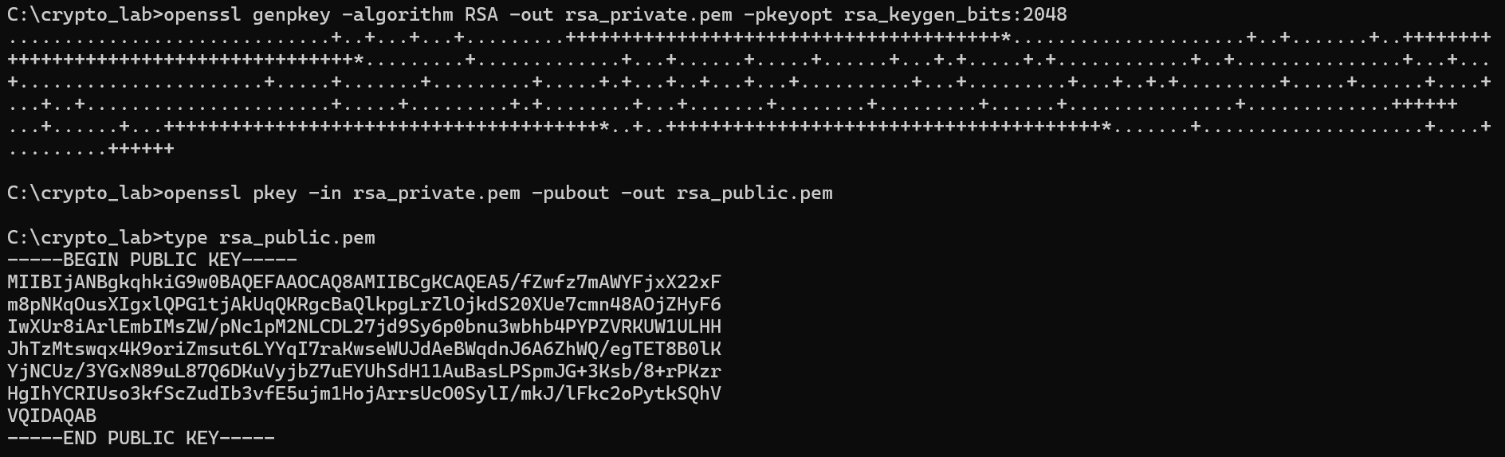RSA Encryption and Decryption
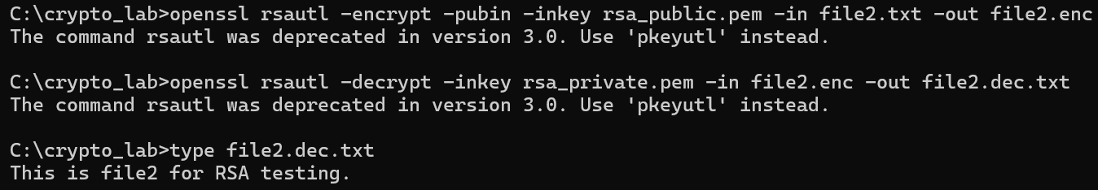Certificate Creation & Viewing
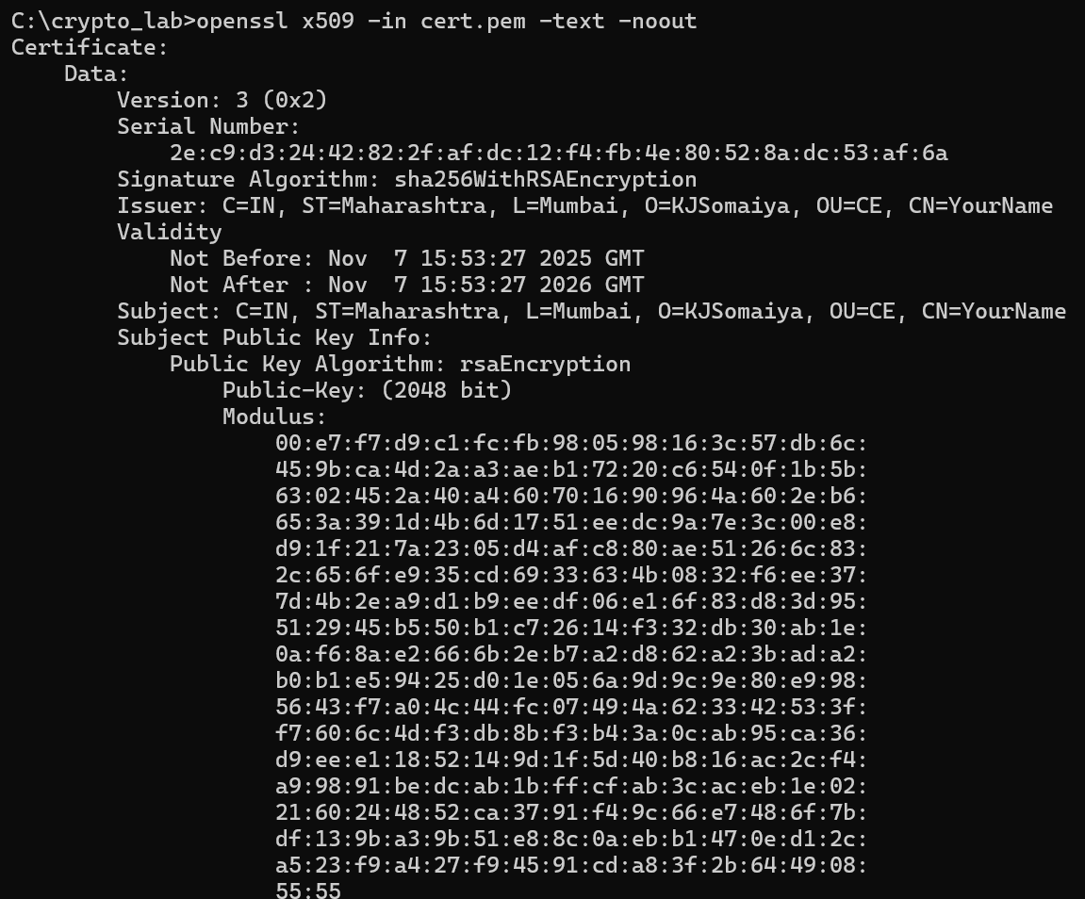
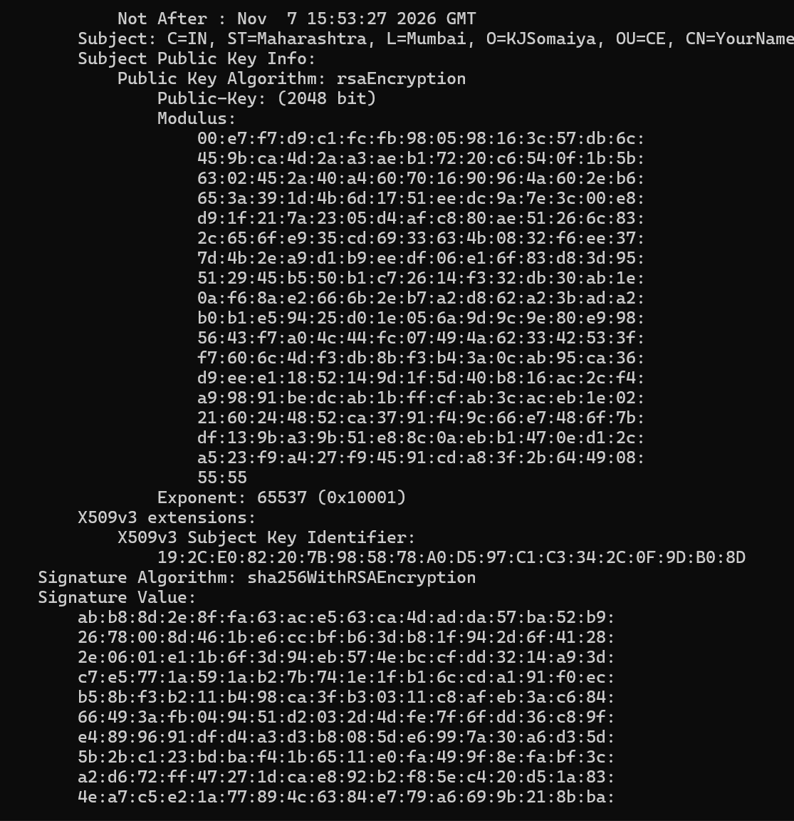Digital Signature (Sign + Verify)

View All Generated Files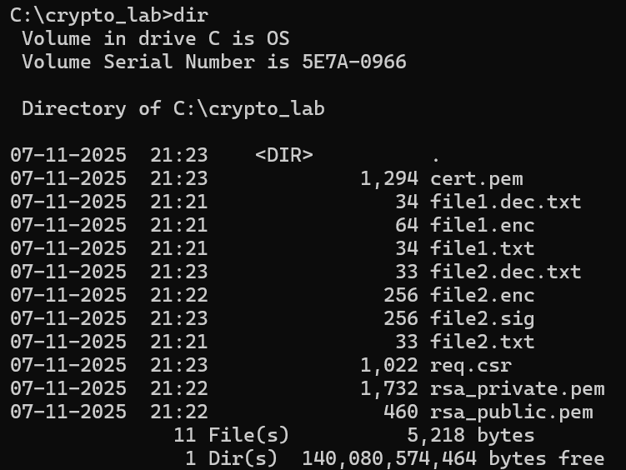
Conclusion:
In this experiment, various cryptographic operations were successfully performed using OpenSSL, including symmetric encryption using AES, RSA key pair generation, RSA encryption and decryption, hashing using SHA-512, digital signature creation and verification, and digital certificate generation. The practical execution demonstrated how confidentiality is achieved through encryption, integrity through hashing, authentication through digital signatures, and non-repudiation through private key-based signing. The experiment provided hands-on understanding of real-world cryptographic tools and strengthened knowledge of implementing modern security mechanisms using OpenSSL.

